SHIVAM PHARMA PACKAGING MACHINE
PLOT NO 91,PLATINUM INDUSTRIAL PARK, SLM MILL COMPOUMD, NR. VATVA RAILWAY STATION, VATVA,AHMEDABAD-382445,GUJARAT
CONTACT:- 7990935706

Date: - 31/08/22
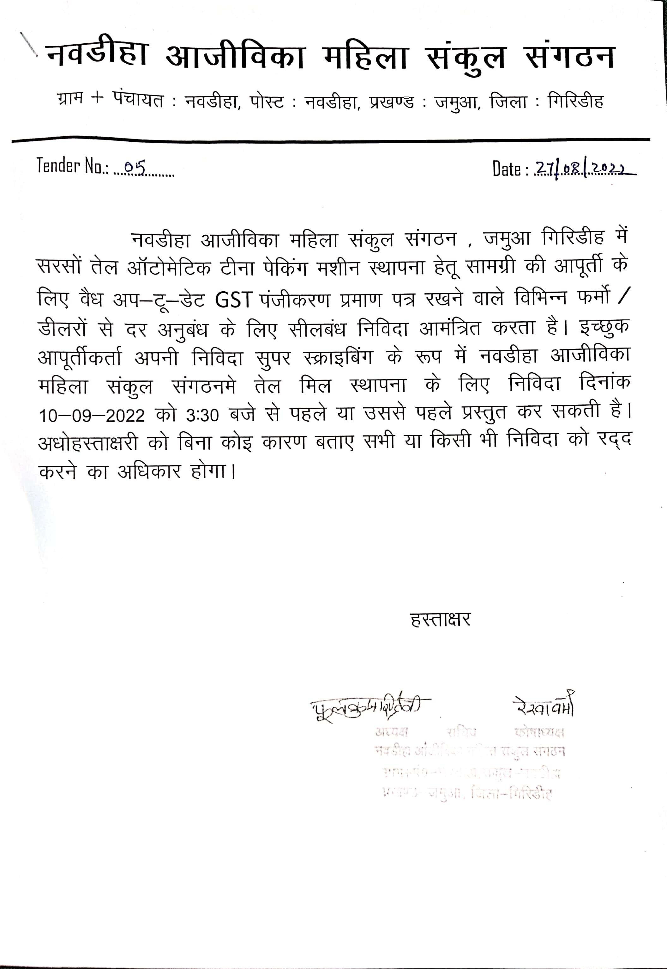

To.
NAUDIHA CLF, JAMUA, GIRIDIH JHARKHAND
PRICE TABLE
NO | MACHINE TYPE | UNIT | PRICE
1 | SEMI AUTOMATIC 1 HEAD 15 KG OIL FILLING MACHINE WITH SEALING MACHINE | 1 | 2,40,000/-
 |  | IGST(18%) | 43,200/-
 |  | TOTAL | 2,83,200/-

THANKS AND REGARDS

SHIVAM PHARMA PACKAGING MACHINE

JANKI OZA

7016520854
SUB:- SEMI AUTOMATIC TIN FILLING AND SEALING MACHINE

Semi Automatic 1 head E-Filling Machine 2 Litr to 15 Litr and cap sealing machine
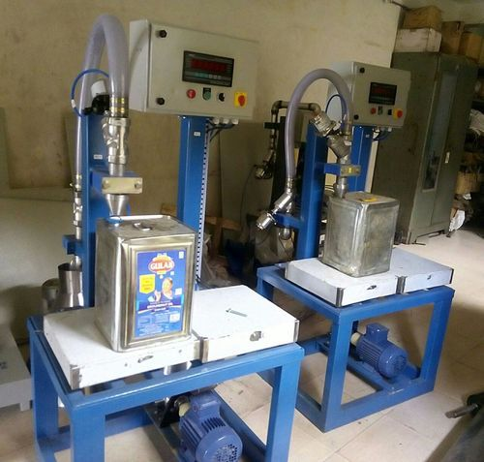
Technical Specifications
Valve Diameter | 20mm
Number of nozzels | 1
Platform Size | 700 x 600 mm
Machine Height | 3 feet approx
Filling System | Load cell Base (Weight base)
Power Consumption | 230 V a.c.
Output per hour | 1 to 1.5 ton per hour( as per 15 ltr)
Salient Features
- ±1 % Filling accuracy on single dose.
- All Contact Parts made of S.S.316
- Rigid vibration free construction for trouble free performance
- A unit to fill variety of liquid and can be used for various types of container

TERMS AND CONDITIONS

1 | PRICE | The prices mentioned are ex our Ahmadabad works
2 | TAXES & DUTIES | 18% extra
3 | TERMS OF PAYMENT | We agreed to have 50% advance and 50 % before Dispatch.
4 | DELIVERY PERIOD | Within 3-4 Weeks from the date of receipt of technically & commercially clear order along with advance payment or receipt of approval for input dimensions, whichever is later
5 | INSURANCE | Transit Insurance against Theft, Pilferage, Breakage, Etc. will be arranged at extra cost at your explicit instruction, otherwise it will be assumed that goods are to be sent at your risk. Cost of such insurance will be as actual to be borne by the consignee.
6 | TRANSPORT | Transportation of the machine from our factory has to be arranged by you. We will arrange for loading of the equipment at our factory. However unloading at site has to be arranged by you. Our responsibility ceases once the goods leave our factory and are handed over to carrier. We do not undertake any liability for damage/ loss in transit whatsoever, whether the goods are insured or not. In case of any damage / accident during transit, the client has to directly deal with the insurance company without holding any payments, irrespective of the insurance arranged by Consigner or Consignee.
7 | INSPECTION | We offer inspection of the machine at our factory, by your technically competent representative, prior to dispatch. This person should be present on our factory during packing and loading of the machine. In case you are not deputing anyone for pre dispatch inspection, then we will not entertain any dispute arising out of short supply, quality, workmanship, functionality, operating parameter, etc. once the machine is  dispatched.
8 | FACTORY TRAINING | We will impart training to your operating staff in our factory before the machine is dispatched, at no additional cost. However, his lodging-boarding and local traveling expenses will have to be borne by you. This person should be technically competent to uncrate and assemble the machine at site before the arrival of our commissioning engineers. He must ensure that ground work necessary at site is competed in all respects before machine. Commissioning, He must be competent enough to be able to run the machine and carry out routine maintenance, once the machine is handed over after commissioning
9 | INSTALLATION | The machine has to be uncarted and placed in working position by you at site. You have to carry out all the external powers and air compressor at site. The machine must be available in the fully assembled condition  when our commissioning engineer arrives at site.
10 | COMMISSIONING | For supervising and commissioning of the machine we will depute one of our engineers on chargeable bases. Customer will have to send a prior intimation of readiness of electrical and utility connections along with required materials.  Rs. 2,000/- per man day will be charged. Customer will reimburse to and for 1st class fare from Ahmedabad to the destination, lodging and boarding expenses and other local expenses for the period of commissioning.

